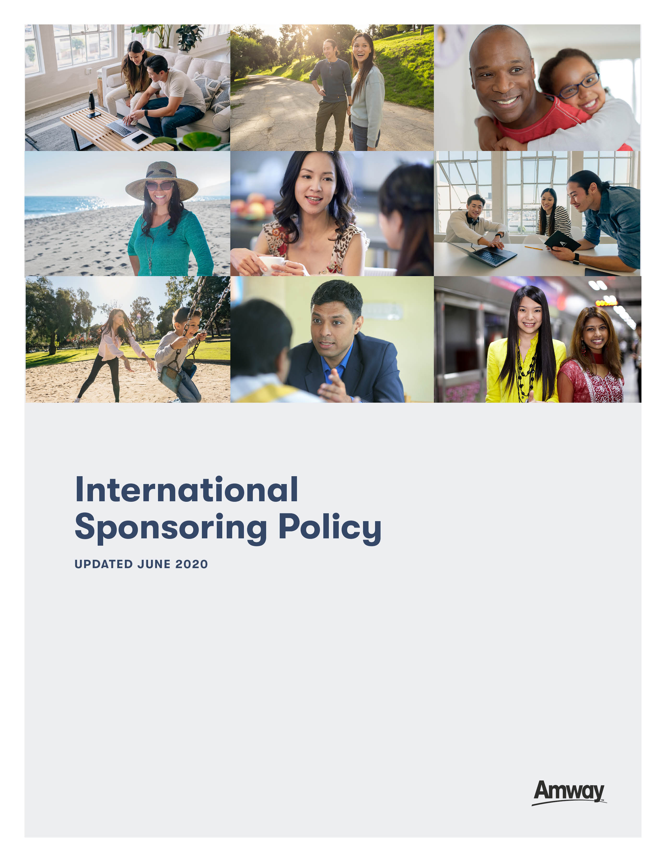

Amway Business Owners (ABOs) may develop their Amway businesses through:  
(I) the international sponsorship of other ABOs; or (II) the establishment and international sponsorship of their own international multiple or second businesses (“Multiple Business”).

International sponsorship of other ABOs and of Multiple Businesses, as well as international solicitation, are governed by applicable laws and regulations and Amway’s Rules of Conduct, Policies, and Commercial Principles as set forth from time to time (Amway Rules of Conduct   
and Policies), including the specific Policies set forth below.

1. **International Sponsorship of Prospective ABOs**

International Sponsoring occurs when an ABO (the International Sponsor) introduces the Amway business to, and subsequently sponsors, a prospective ABO in another market (the Internationally Sponsored ABO). The International Sponsor will provide offshore support to the Internationally Sponsored ABO, who will also be provided an in-market sponsor (the Foster Sponsor).

* 1. An International Sponsor has initial and ongoing obligations to their Internationally Sponsored ABO(s).
     1. The International Sponsor must:
        1. Personally know and introduce the business to the Internationally Sponsored ABO, such that the Internationally Sponsored ABO identifies the International Sponsor when registering with Amway;
        2. Arrange, either directly or through Amway, for a Foster Sponsor to locally sponsor the Internationally Sponsored ABO;
        3. Communicate with the Internationally Sponsored ABO periodically , encouraging the Internationally Sponsored ABO to build the business in a manner appropriate to the market and consistent with the contractual obligations the local ABO has to the Amway affiliate; and
        4. Communicate with and provide support to the Foster Sponsor as the Foster Sponsor provides ongoing in-market support to the Internationally Sponsored ABO.
     2. The International Sponsor cannot:
        1. Interfere with the Foster Sponsor’s provision of support and training to the Internationally Sponsored ABO;
        2. Conduct business in the market beyond the extent allowed by applicable law and the Amway Rules of Conduct and Policies;
        3. Present the Amway Sales and Marketing Plan for that market to the prospective ABO (that is the role of the Foster Sponsor and/or the local Amway affiliate); or
        4. Share or ship products, literature, sales aids, or training materials from outside the Internationally Sponsored ABO’s market to the Internationally Sponsored ABO.
     3. The International Sponsor should fulfill all responsibilities as an International Sponsor from outside the market where the Internationally Sponsored ABO is located. The International Sponsor may only travel to the international market as needed from time to time and as allowed by applicable law.
  2. The Foster Sponsor’s role is to present and explain the Amway Sales and Marketing Plan to the Internationally Sponsored ABO and has ongoing responsibility for the training, education, and motivation of the Internationally Sponsored ABO as provided for in the Amway Rules of Conduct and Policies.
  3. The Internationally Sponsored ABO places the International Sponsor’s and Foster Sponsor’s name and ABO number on the application at the time of registration.
     1. While every prospect must have an in-market sponsor in order to become an ABO, not every prospect has to have an International Sponsor. Only in those instances when a prospect is introduced into the business by an ABO from another Amway market should the prospect’s application reflect that ABO as their International Sponsor.
     2. The Internationally Sponsored ABO only identifies an International Sponsor if that person personally introduced them to the Amway business.
     3. After the Internationally Sponsored ABO’s registration has been submitted to and accepted by Amway, any change to the International Sponsor can only be undertaken in accordance with Amway Rules of Conduct and Policies.
  4. When establishing an international link/s, it is important for the International Sponsor to understand that Amway, at its sole discretion, may refuse to recognize and/or pay compensation under the Amway Sales and Marketing Plan to any structure which Amway determines is a market plan distortion.

1. **International Sponsorship of a Multiple Business**

In numerous Amway markets, the law allows a foreigner to own and operate an Amway business. If an ABO decides to register a second business in a market different from the market of their original business, the second business must be internationally sponsored by the original business. Subsequent business (third, fourth, etc.) must also be internationally linked to either the original business or one of the other businesses.

* 1. Effective January 1, 2015, in order to establish a Multiple Business in another market, an ABO must be at least a currently Qualified Platinum in an Amway market. Exceptions to this requirement are:
     1. An ABO residing outside of their home market if the ABO can provide proof of residency and is eligible to own and operate an Amway business in the target market.
     2. An ABO who has an immediate family member in the target market. Immediate family member is defined as parents, siblings, and children.

In addition, certain markets may impose more stringent requirements. For example, Amway China Sales Representatives must be at the Sr Sales Manager level or above and Amway Japan Distributors must be a Diamond Bonus Recipient (DBR) in the prior Performance Year in order to be eligible to register a Multiple Business in another Amway market.

For those ABOs setting up a Multiple Business within Europe who already have an existing business there, the Qualified Platinum requirement does not apply however, their Multiple Business must be internationally linked by the original business in Europe.

* 1. Before establishing a Multiple Business, foreign ABOs must adhere to local laws and regulations. In addition, Multiple Business owners must fulfill their responsibilities as sponsors in the international market; they must build balanced Multiple Businesses, including personally providing training and support to their downline ABOs or, alternatively, making arrangements for the provision of the same according to Amway’s Rules of Conduct and Policies.
  2. Effective September 1, 2017, once an ABO establishes a Multiple Business in an Amway market, the ABO may only Internationally Sponsor new ABOs downline of that Multiple Business. Any international sponsorship established prior to September 1, 2017, will not be impacted.

1. **International Solicitation Policy**

When registering a Multiple Business with Amway, ABOs can make their own decision identifying a sponsor and are not required to join the same Line of Sponsorship in all markets. However, ABOs are encouraged to check with their uplines to find out if ABOs from the original home market Line of Sponsorship already have a second business established in the target market as this can help preserve LOS harmony and can provide guidance and assistance to an ABO considering starting a business in a foreign market.

ABOs are not allowed to solicit ABOs they have not personally sponsored to register downline from them in other markets. This is a violation of Amway’s Rules of Conduct and is prohibited.

* 1. ABOs may only approach personally sponsored ABOs to discuss their interest in starting a Multiple Business and being sponsored by them in that market. Soliciting any other existing ABO is a violation of Amway Rules of Conduct and Policies.
  2. Some markets are more restrictive when building a Multiple Business and do not allow the solictatoin of *any* ABO, including personally sponsored ABOs. It is the responsibility of each ABO to consult with the local Amway affiliate regarding local rules and policies.